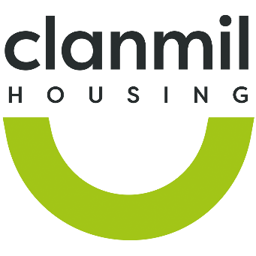

CLANMIL NEIGHBOURHOOD FUND

FUNDING PRIORITIES
Community Development Projects on your patch should be developed in line with local needs. Where applicable tenants should be involved in the development and decision making in relation to applications.
Funding is for activities that meet the following priority areas:
- Child and Youth related projects
- Older people related projects
- Community projects
- Family projects
- Health and wellbeing projects

FUNDING
Projects should be up to £1,000 with each NSO having a budget for an average of £4,000 per annum. Each application will be reviewed on a case by case basis.

TIMESCALES, MONITORING AND REPORTING
We will contact all applicants within 2 weeks of application to discuss your application. If successful we ask that all NSO’s complete the project budget spend & evaluation templates which will accompany your confirmation of funding award email.

HOW TO APPLY
To apply, please request and return your completed application form by email: neighbourhoodfund@clanmil.org.uk

SECTION ONE: CONTACT DETAILS & PROJECT DETAILS

Project Name

Responsible NSO Contact:

Email:
Name: ILS/ CAT1/General Needs:

Patch Name:

Super Patch Name:

Anticipated Project Delivery Timescale:
Project Start Date:
Project End Date:
Amount Requested/ Breakdown of Costs

List the priority area(s) your project meets –

Does your project require Assets/ Maintenance staff assistance?

Is a Risk Assessment Required?

SECTION TWO: ABOUT YOUR PROJECT
Please tell us a little bit about your proposed project.

What practical difference do you want to make through this project?

Anticipated Beneficiary Numbers:

Tenants Involvement:

Community Involvement:

DECLARATION:

Print Name:

Date Application Submitted:

