Marriott House
Housing with Care

Statement of Purpose

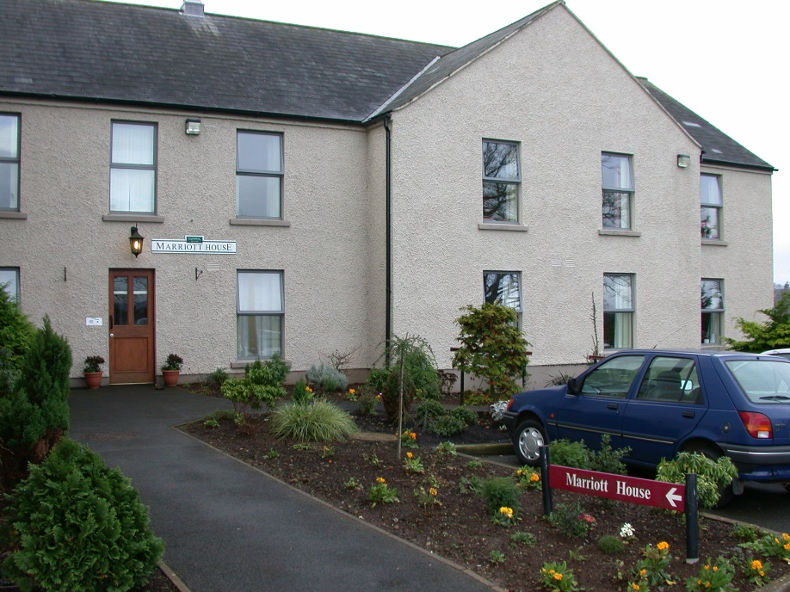

30 Castledawson Road
Magherafelt
BT45 6EF

Telephone: 028 7930 1100

Care Home Manager: Geraldine McCann
Email:geraldine.mccann@clanmil.org.uk

This version published May 2026

Contents
Introduction 3
1. (a) Registered Provider 3
(b) Registered Person 3
2. Registered Manager 4
3. Number and relevant qualification and experience of staff 4
4. Philosophy of Care 5
5. Status and constitution of homes 8
6. Organisational Structure of Marriott House 8
7. Number of residents to be accommodated at Marriott House 8
8. The range of needs (categories of care) that Marriott House is intended to meet and the number in each category 8
9. Admission criteria including the home’s policies and procedures for emergency admissions 9
10. Arrangements for residents to engage in social activities, hobbies, and leisure interests 10
11. Arrangements in place for consultation with residents about the operation of the home 10
12. Fire precautions and associated emergency procedures 11
13. Arrangements in place for meeting residents’ spiritual needs / attendance at religious or belief services of their choice 11
14. Arrangements in place for social contact with relatives / friends / representatives / local community where practicable 12
15. Arrangements for dealing with complaints 12
16. The arrangements made for dealing with reviews of the resident’s care plan 15
17. The number and size of rooms in Marriott House 15
18. Details of any specific (therapeutic) techniques used in Marriott House, and arrangements made for their supervision. 16
19. The arrangements made for respecting privacy and dignity of the residents 16
20. Date approved and implemented 17
21. Dates of review and record of changes made 17

Introduction

Marriott House is one of three Housing with Care homes owned and managed by Clanmil Housing Association. The purpose of Marriott House is to provide high-quality and person-centred care and support for up to 13 residents. Staff in Marriott House aim to provide an environment where residents are treated with respect and dignity, are valued as individuals and are supported to continue to have a meaningful life.

Marriott House is registered with The Regulation and Quality Improvement Authority (RQIA) to accept the following categories under residential care.

Category Definition
RC-DE Residential Care – Dementia (Maximum of 5 residents in RC-DE category of care.
RC-I Residential Care – Old Age not falling within any other category.

RQIA inspection reports can be viewed at www.rqia.org.uk

Marriott House currently has five beds registered for people with dementia.

(a) Registered Provider

Clanmil Housing Association
Northern Whig House
3 Waring Street
Belfast
BT1 2DX

(b) Registered Person

Mrs Carol McTaggart
Group Chief Executive
Clanmil Housing Association
Northern Whig House
3 Waring Street
Belfast
BT1 2DX

Carol McTaggart is the Group Chief Executive of Clanmil Housing Association.

Carol has worked in the housing sector in Northern Ireland for more than 30 years. She has extensive knowledge and experience in the delivery of new

homes, regeneration, and strategic asset management. She became Chief Executive of Clanmil in January 2022.

She is also the Chair of the Chartered Institute of Housing in Northern Ireland and a board member of the Northern Ireland Federation of Housing Associations.

Registered Manager
Geraldine McCann
Marriott House
30 Castledawson Road
Magherafelt
BT45 6EF

The registered Care Home Manager is Geraldine McCann. Geraldine has worked in the care sector for 25 years including in care of the elderly, mental health, dementia, and holds Level 5 Award in Leadership and Management. She has worked as a Care Home Manager for three years and has worked for Clanmil for two years.

Number and relevant qualification and experience of staff

a. Staffing arrangements / fitness to practice of care staff

Trained staff are on site 24 hours a day 365 days a year to deliver care and support to residents in Marriott House. The Home has a Registered Manager who manages a team of Senior Care Assistants, Care Assistants and Catering staff as well as the Domestic team. The Registered Manager has full responsibility for ensuring all residents’ needs are met and staff fulfil their obligations in terms of care quality and service delivery.

Marriott House staff are recruited in line with Clanmil Housing’s Recruitment Policy (2022). When recruited, all staff undertake an induction process and complete mandatory training to ensure they have the required essential skills to carry out their role within a residential setting. There is a requirement for staff to attend specialised dementia training to ensure the necessary knowledge and skills are developed to support people living with dementia.

Since 2017, employees who provide social care are required to register with the Northern Ireland Social Care Council (NISCC)

In the Registered Manager’s absence, the Senior Care Assistants have day-to-day responsibility for issues arising but are required to report through to the Registered Manager in the first instance. The Senior Care Assistant role has line management responsibility for several care staff and designated key worker

responsibility for residents. For longer periods of absence, cover will be provided by a neighbouring Registered Manager.

Marriott House also has two Relief Senior Care Assistant positions. These roles are held by designated Care Assistants. The Relief Senior Care Assistants are fully trained in the duties and responsibilities of a Senior Care Assistant and provide temporary Senior Care Assistant cover during short periods of absence.

The Marriott House staff team consists of:
- Three x Senior Care Assistants (full time)
- Two x Cooks (One full time and one part time)
- Two x Domestic Staff (full time equivalent)
- 10 Care Assistants (three full time, seven part time)

b. Staff Training and Development

The number, qualifications, and experience of staff within the home will vary from time to time. However, minimum RQIA guidelines on staff experience and qualifications will be adhered to, and in some cases, will be exceeded. Residents have the benefit of experienced, trained, and professional staff who can assist and empower them in all areas of their daily living. Staff training is recorded on a training matrix to assist with identifying training needs.

The Senior Care Assistant is key worker to a specific number of residents. They are responsible for developing residents holistic care and support plans, co-ordinating reviews or meetings and communicating with other service providers. Care Assistants will always undertake their tasks in a reliable and professional manner and a resident can expect all staff to be properly trained, courteous, approachable and professional at all times.

Clanmil recruits staff with appropriate skills and experience in the delivery of quality care services and provides comprehensive training and development opportunities for all staff in accordance with legislative and regulatory requirements.

Philosophy of Care

Marriott House aims to provide a warm, relaxed, and homely environment where residents are supported to achieve their maximum potential.

When someone is assessed as no longer able to remain in their own home, or they have not been placed in the right setting for their needs, we welcome them to Marriott House when they are assessed as suitable for residential housing with care by Northern HSC Trust.

Some residents may have mild to moderate dementia, physical health issues or a combination of both.

We offer a balance of care and support by providing a tailored and detailed package designed to meet their individual needs and choices, empowering them to lead fulfilling and meaningful lives, while enjoying the benefits that communal living offers, such as safety, security, and friendship.

We encourage residents to make choices and share their opinions, so that we can work with them to provide the care and support that will help them thrive physically, emotionally and spiritually.

It’s also important that we work with residents to maintain links with their past, while enjoying the present and having confidence in the future.

While our focus on the resident’s needs, we will also consult with their family members to ensure they are getting the right level of care and support, and that plans are drawn up with the agreement of everyone involved.

Our aims are to:
- Provide each resident with the privacy, security, and independence of their own flatlet.
- Offer personal sensitive care and support, respecting the needs of the individual and avoiding restrictive practices by actively promoting the core values of privacy, dignity, independence, rights, choice, and fulfilment and embedding this as the ethos of the home
- Maintain housekeeping to a very high standard.
- Provide meals that are home cooked onsite, using fresh and healthy ingredients.
- Work to a person-centred care ethos, focussing on strengths, goals, and achievements.
- Enable residents to live in an environment that is warm, homely, relaxed, and supportive.
- Involve residents and their family members in reviewing and improving the quality and effectiveness of the care and support provided.
- Support residents in all aspects of daily living, empowering them to exercise choice and maximise their independence including the potential risks involved in doing so.
- To work in partnership with a range of professional, to provide an integrated, holistic, flexible service that is person centred.

Objectives of Marriott House:
- Provision of a dedicated team of staff to assist residents with daily living tasks over 24 hours a day.

- Promotion of the individuality and independence of each resident.
- Focussing on supporting residents by ‘doing with’ rather than ‘doing for’.
- Providing accommodation that includes assistive technology for residents who are frail elderly and those with dementia, in keeping with the registered category of the Home.
- Promote active ageing and combat isolation through the provision of activities and actively encouraging residents to participate where possible
- Ensuring the safety of residents is paramount with the use of an electronic door system which can only be opened internally by staff and residents have access to the door code, if deemed appropriate following assessment.
- Providing care to residents who may be of mixed gender or ethnic origin.
- To provide care that avoids discrimination and promotes equality of opportunity including for;
  - persons of different religious belief, political opinion, racial group, age, marital status or sexual orientation
  - men and women generally
  - persons with a disability and persons without
  - persons with dependants and persons without

- Meeting the needs of residents by means of ongoing ‘assessment of need’, which is agreed and detailed in individual resident care and support plans. Any nursing, dentistry, and chiropody services will be supplied by the relevant community service provider or alternative as selected by the resident.
- Building links with the local community and involving residents in this.
- Ensuring all staff adhere to the NISCC code of practice and standards and commit themselves to ongoing training and personal development.
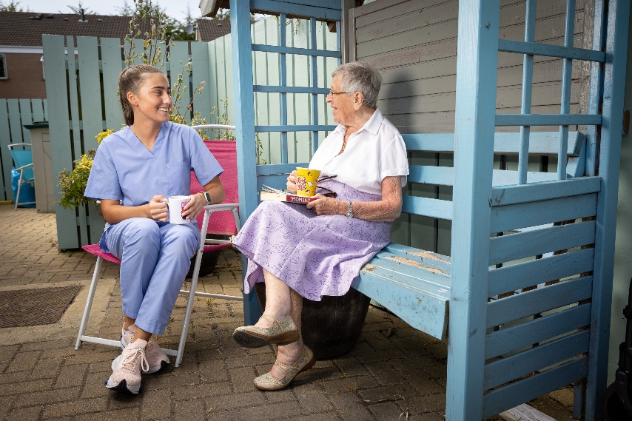

Status and constitution of homes

Marriott House is a residential care home owned by a voluntary organisation (Clanmil Housing) and registered under Article 8 (1) of the Health & Personal Social Services (Quality, Improvement, and Regulation) (Northern Ireland) Order 2003.

Organisational Structure of Marriott House

Carol McTaggart
Group Chief Executive - Registered Person
Pól Callaghan
Executive Director for Customer and Communities
Brendan Morrissey
Assistant Director Housing and Communities
Caroline McWilliams
Older Peoples Services Manager
 |  |  | Geraldine Boyce –Home Manager - Registered Manager
Senior Care Assistants x 3 |  |  |  |  |  |  | Care Assistants x 10
Support Service
Cooks x 2
Domestic Assistants x 2

Number of residents to be accommodated at Marriott House
The home is registered as a Residential Care Home by the Regulation & Quality Improvement Authority (RQIA) to have 13 residents and to provide care and support services to all.

The range of needs (categories of care) that Marriott House is intended to meet and the number in each category

Marriott House has five beds registered for dementia need. Residents who have dementia will only be admitted to the home where their dementia is low to moderate. Marriott House does not provide care for residents in the latter stages of dementia.

Admission criteria including the home’s policies and procedures for emergency admissions

New residents may only be admitted to the home following assessment by Northern HSC Trust showing that they meet the criteria for our registered category in line with registration boundaries.

(a) Planned Admissions

The Registered Manager will review the appropriateness of the admission in consideration of the current number of residents, the current dependency levels, and any issues, which need to be addressed prior to admission.

All residents will meet the registration criteria as set out in the Admissions Policy which will include:
- Have either;
  - (a) a diagnosis of dementia (mild / moderate / early stages) or
  - (b) a probable diagnosis of dementia - Individuals who are undergoing ongoing assessment awaiting a formal diagnosis are to follow the instructions within the guidance for Admissions to Care Homes Registered for Dementia
- Assessed need for residential care with nursing needs that can be provided by the district nursing team.
- The person can mobilise and transfer independently or with minimal assistance. This will be discussed with referrer at time of assessment.
- The person is independent or requires the assistance of only one person with personal care.
- The person should be able to eat independently with relevant prompts and support.
- The person consents to the admission (where appropriate).

The assessor will ask if a Deprivation of Liberty (DoL) Order is in place.

The Trust Social Worker will coordinate out a post-admission review for each resident six to eight weeks after admission. This will include the resident, relatives, Care Home Placement Team and any other relevant professionals.

(b) Emergency Admissions
There may be occasions when it is necessary to admit a resident in an emergency. When such emergencies occur, full information may not be available on admission. The information should be obtained the next working day from the resident’s key worker (Senior Care Assistant). It is, however, essential that basic information regarding the person’s GP, medication prescribed and next of kin is available at admission. The Registered Manager

shall ensure that a risk assessment is carried out at the time of admission so that appropriate safeguarding and care arrangements are in place.

Arrangements for residents to engage in social activities, hobbies, and leisure interests

A varied range of activities including social events are organised by staff and residents. Residents will always have a personal choice about how they spend their leisure time. Staff will facilitate and assist as required. Activities will include music nights, film evenings, craft classes, outings, party nights, quizzes and bingo evenings, family fun and BBQ days, reminiscence, life history groups, and facilitated exercises classes. Our activities are tailored to the needs of each resident.

Each resident is personally invited to all events and notices are also in place to invite and inform family members. If a resident chooses an activity, staff will do all they can to help them participate and enjoy it fully.

Each resident’s file will have details of next of kin and who the contactable person is, so that they will know when and where activities take place.

We aim to encourage and facilitate residents to use any skills or hobbies they enjoyed before moving into the home, such as housework, baking, gardening etc.

Arrangements in place for consultation with residents about the operation of the home

The ability and opportunity for residents to have a say in how the home is run is very important to us at Clanmil. We will use the following ways to help us to tailor the running of the home to the wishes of the residents:
- Residents’ meetings
- Yearly resident and family satisfaction surveys
- Formal and informal discussions with staff and the Registered Manager.
- Staff from Clanmil will phone residents’ family and friends occasionally to ask them for their views on the care provided in the home. This is part of our quality assurance process.
- Residents and families are encouraged to meet with inspectors from the RQIA. Information from the RQIA is prominently displayed in the home, together with the last inspection report.
- Senior managers from Clanmil visit Marriott House on a regular basis to ensure that consultation with relatives and/or residents is consistently happening, so that a quality service is being provided. Clanmil is committed to ongoing consultation with residents of Marriott House to ensure resident involvement in all aspects of service delivery.

- Monthly inspection audits are carried out by Clanmil colleagues at Marriott House during which the environment and record keeping is checked. Auditors will also speak with residents, staff and family/visitors. The auditor will report their findings to the Registered Manager.
- Clanmil will set out the schedule of types of inspection audits of the home and will publish this on the home noticeboard.

Fire precautions and associated emergency procedures

Marriott House fire safety and evacuation procedures operate within the Regulations 27 (4)(a), (b), (c), (d), (e), (f) of the Nursing Homes and Residential Care Homes Regulations.

All staff are trained in fire prevention and safety, and this is updated every six months as part of mandatory training. The Care Home Manager and Senior Care Assistants have been trained as fire wardens. They ensure that all staff and residents adhere to procedures. Regular fire safety checks are carried out as specified in the Clanmil’s Fire Safety Policy (2023). All residents have a Personal Emergency Evacuation Plan (PEEP) completed on admission and residents’ input into this is sought.

Marriott House has a fully operational fire alarm system and firefighting equipment distributed in designated areas. In line with the Fire Safety Policy, all fire exits are clearly marked with appropriate lighting. Marriott House has a battery back-up to maintain emergency lighting for three hours in the event of a power failure. There is also an emergency grab bag onsite that contains:
- First Aid Kit
- Foil Blankets
- Battery operated torches.
- Residents’ details sheets (GP / Emergency contact /Social Worker / medical details)

There is an identified designated smoking area for residents. Staff adhere to Clanmil’s Smoking Policy. Fire doors at Marriott House are operated on automatic closure system to ensure compartmentalisation. An external consultant carries out a yearly fire risk assessment.

Marriott House also has a Business Continuity Plan (BCP) in place and staff are updated regularly as to how to implement this plan. Clanmil’s Corporate Health and Safety Manager monitors all these procedures.

Arrangements in place for meeting residents’ spiritual needs / attendance at religious or belief services of their choice

As part of individual care plans, consideration is given to the spiritual needs for each resident and arrangements can be made for local clergy or spiritual or humanist celebrants to visit. Religious, spiritual or humanist services can be

held within Marriott House to facilitate all denominations, and arrangements can be made for those residents who wish to attend their local church.

Residents will have the privacy to practice their own religious or belief observance and if they wish to display religious or other belief artefacts in their own rooms.

Arrangements in place for social contact with relatives / friends / representatives / local community where practicable

Marriott House welcomes visitors. If required and if requested by the resident, staff will contact other persons by phone or letter. Residents are encouraged to invite visitors for meals and social events in the home. They are supported to facilitate visitors to their own individual rooms. Refreshments will be provided as required.
All visitors are required to sign in and out of the home and to make themselves known to home staff. This is for the safety and protection of residents, staff and visitors. There will not normally be restrictions on when people can visit.

Staff will assist residents who have communication difficulties to contact their relatives in private. Residents have access to the phone with staff support and can have phones installed in their rooms at their personal cost.

Arrangements are made to deliver mail to residents’ rooms. A facility can be set up for residents to maintain contact with relatives abroad via the Marriott House Facebook messenger page.

Relatives are encouraged to accompany residents to hospital appointments.

Arrangements for dealing with complaints

Our commitment

We recognise that resident feedback is important. While we intend to provide a great service, we acknowledge that from time-to-time things can go wrong, and it may be necessary to raise a complaint to us.

We welcome complaints as an opportunity for improvement and change. We will ensure that we are responding to complaints effectively and fairly, to create a positive, open, and non-defensive complaint handling culture. We will learn from resident feedback to help us improve the experience for other residents.

We will actively listen and discuss complaints with our residents, keeping the relevant parties updated throughout the process. We will focus our efforts on putting things right and finding a resolution as quickly as we can.

On admission to the home, residents are provided with a copy of the Residents Guide which incorporates the Compliments, Comments and Complaints policy. A copy of this policy is also displayed on the home notice board,

For those with sensory limitations the format can be provided in a suitable manner for them, it is also available in languages other than English. A translation service is also available if needed.

Compliments

We recognise that residents and their families, visitors may have feedback other than complaints. We welcome and monitor all feedback, including compliments, suggestions, and resident and family satisfaction survey comments.

The comments the residents and their family make in response to our customer satisfaction surveys will be monitored, assigned, and reported on by the Customer Insight Analyst on a regular basis.

If you make a compliment, we will share it with all colleagues to recognise the hard work and identify the areas in which we perform well. Comments, compliments, and suggestions can be passed to Clanmil using any communication method, including the dedicated email address:

customerfeedback@clanmil.org.uk

Complaints

Complaints in Marriott House will be addressed under Clanmil’s Complaints Policy. Complaints can be brought to the attention of either to the Care Home Manager or Clanmil Head Office. Initially, complaints will be addressed by the Care Home Manager. We call this ‘Make it Right’. All complaints will also be reviewed by the Older People Services Manager and reported for monitoring to Clanmil's Business Assurance Team. Specific guidance on the action to be taken by staff on the receipt of complaints is included in procedures to be followed. Where the person making the complaint remains dissatisfied, they should contact Clanmil’s Head Office at:

Telephone: 028 90876000
Email: complaints@clanmil.org.uk
Website: www.clanmil.org.uk

A copy of Clanmil’s complaints policy is available from the Home Manager or Clanmil Head office. We have two formal complaint stages. Stage One is the entry point to our formal complaints process. We will aim to respond to your

Stage One complaint normally within 10 working days, and we will issue our response in writing.

If you remain dissatisfied, you can appeal the decision. We call this Stage 2. The review of your complaint at Stage Two will be carried out by a Director or an Assistant Director. The Investigating person will make contact with you to discuss the points of dissatisfaction and they will respond to you formally, in writing, normally within 20 working days.

If you remain dissatisfied with the Stage 2 response, you have the option of referring the matter to Northern Ireland Public Services Ombudsman (NIPSO) who will assess whether there is evidence of service failure or maladministration which has not been identified by Clanmil at Stage 2.

For the Ombudsman to consider your complaint, you must log it with them within 6 months of the date of the final response at Stage 2 of our process. We have provided the contact details below:

Northern Ireland Public Services Ombudsman
Progressive House
33 – 37 Wellington Place
Belfast BT1 6HN
Tel: 028 9023 3821 nipso@nipso.org.uk

Where Clanmil provides services which are regulated by RQIA, complaints are managed in accordance with The Health and Social Care Complaints Procedure Directions (Northern Ireland) 2009 (DHSSPS)

When a complaint has been made about a Clanmil Care Home, the Regulation and Improvement Authority (RQIA) will, as part of their inspection process, review complaints to assess the effectiveness of our complaints processes to see if there are any wider issues for the purpose of raising standards. RQIA can be contacted at:

RQIA
9th Floor Riverside Tower
5 Lanyon Place
Belfast
BT1 3BT

Tel: 028 9051 7500 Email: Info@rqia.org.uk

Residents may also contact RQIA or Northern Health and Social Care Trust directly should a complaint arise in respect of the quality or delivery of residential care services by Clanmil.

Safeguarding

Any safeguarding concern at Marriott House will be addressed in accordance with Clanmil’s Adults At Risk Safeguarding and Protection Policy (2022). A complaint that relates to the suspected abuse or neglect of a resident at any of the care homes is immediately reportable to the RQIA. The Care Home Manager reports to the Care Home Placement Team at the Northern Health & Social Care Trust, and any affected resident’s Social Worker(s). Clanmil also has internal Safeguarding Champions.

Due to the complexities of these types of complaints set timeframes for closure cannot be confirmed. The Care Home Manager will remain in contact will all the above organisations until as such times as the safeguarding complaint is closed to everyone’s satisfaction.

Learning from complaints

We view complaints as an opportunity for learning. Once a compliant has been investigated and closed the Care Home Manager and Older Peoples Services Manager will review the findings and implement all recommendations for improvement.

The arrangements made for dealing with reviews of the resident’s care plan

Formal reviews of the resident’s care and support plans will be held at a mutually agreed time and date. This is usually organised annually by the residents Social Worker. The care plans are reviewed by the Senior Care Assistant and in turn audited each month by the Care Home Manager to ensure that they continue to be both relevant and achievable and meet the needs of the resident. The resident and their family are involved in this process (with the resident’s permission) and information is only shared with others as detailed in the disclosure of information form.

The number and size of rooms in Marriott House

Rooms
Marriott House has 13 single furnished ensuite rooms. Room size ranges from 17.20 m² to 18.00m².

Residents are encouraged to personalise their rooms making sure any furniture they wish to bring with them meets fire retardant regulations.

Facilities in Marriott House
- Oil Fired Central Heating
- Wi-Fi in communal areas

- Dining room
- Two fully furnished day room with TV
- Full meals service
- Foyer seating area
- Laundry room
- Patio areas and landscaped gardens
- Assisted parker bath / shower room.
- Lift to 1st floor
- Full fire protection system

Details of any specific (therapeutic) techniques used in Marriott House, and arrangements made for their supervision.

Activities for residents are occasionally provided by external organisations as a one off or for longer periods. These sessions are risk assessed and supervised by Marriott House staff. The activity providers report to the Senior Care Assistant at the end of the session to update them on the participation and progress made of individual residents, as well as providing an overall view of the group dynamics

The information given will be used for residents’ daily recordings, monthly summaries, and yearly reviews. This will also enable staff to monitor and review the sessions, their effectiveness and the value to each resident involved.

How individual residents spend their leisure time will always be a matter of personal choice. Staff will facilitate and assist as required.

The arrangements made for respecting privacy and dignity of the residents

The core care values are central to all that we do in Marriott House. Some include:

- All residents will be addressed by the name of their choice.
- Staff will knock and wait before entering the resident's room.
- All resident’s information is strictly confidential, and staff have training in this area.
- All residents are offered a choice of two meals at each mealtime. Dietary requirements and personal tastes are accommodated.
- Residents decide for themselves when to rise and go to bed.
- The right of the resident to choose is central to our ethos.

Within Marriott House arrangements are in place to respect residents’ privacy and dignity. Staff ensure that all residents have a right to privacy and adhere to the standards set out in the homes operational policies and procedures.

Ongoing training is provided to staff on the core values of privacy, dignity, and respect. Senior staff monitor daily staff members’ adherence to these values. The resident’s care plan will take account of their rights to privacy and dignity, indicating clearly the agreement of the resident’s’ choice in these areas. There may be occasions when total privacy may not be possible due to or identified risks and/or care interventions, which need to be carried out by staff. This will be clearly documented in the care plan so that boundaries are fully set out and understood by residents, family (where consented by the resident), social services and other relevant partners as required.

On admission, it will be explained to residents that they will be living in a group living setting and on occasions this could impinge on an individual’s privacy. However, every effort will be made to minimise this, by providing private areas for visitors, having respect for residents’ individual bedrooms and minimising any environmental restrictions which may be beyond our control.

When they move into Marriott House, residents will be given every opportunity to maintain their individuality, freedom of choice, rights and citizenship. They will have an opportunity for enjoying a dignified, fulfilled, and independent life. All care interventions and social activities will be individualised to consider history, lifestyle and current capabilities, and will be tailored to include a resident’s choice and preferences to maintain their dignity.

Date approved and implemented

This Statement of Purpose was amended and implemented in December 2024. It will be reviewed after 3 years or earlier as appropriate.

Dates of review and record of changes made

January 2025 |  | Full review and consolidation of individual home templates into single format.

